How to expand wireless network’s coverage through WDS function

Product line: wireless question category: function config

Sometimes the wireless router is too far from the wireless clients or the wireless signal strength is too low to connect, in order to expand the wireless coverage of your existed wireless router, you can setup WDS on the other wireless router.

The Topology is as below:
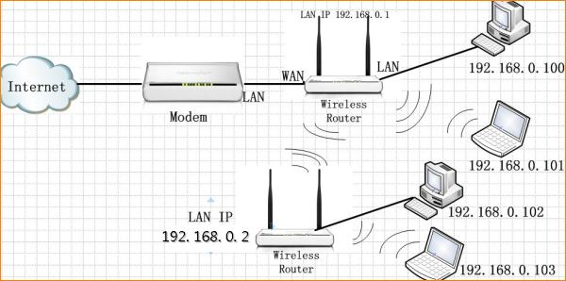
Key points:
1. Both routers should support WDS function;
2. The LAN IP addresses of the two routers should be two different IP within the same IP segment (192.168.0.1), for example, R1: 192.168.0.1, R2: 192.168.0.2;
3. The DHCP Server of R1 should be enabled, while the R2’s DHCP Server should be disabled;
4. The wireless settings of both routers should be exactly the same, including SSID, channel, security mode, algorithms and password.

The Steps are as below:

Settings in R1 which has been setup for internet:
1. Open a web browser in PC1 which connects to R1, and in the address bar please type in 192.168.0.1(the LAN IP of the router), and then click Enter. Then you will be in the management page of R1.

2. Click on the Advanced Settings to go into the advanced settings page.

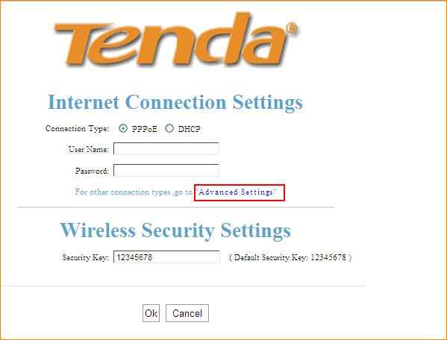

3. Click on Wireless Settings, then in the Wireless Basic Settings page, change the SSID and select Channel 6, then click OK to save.
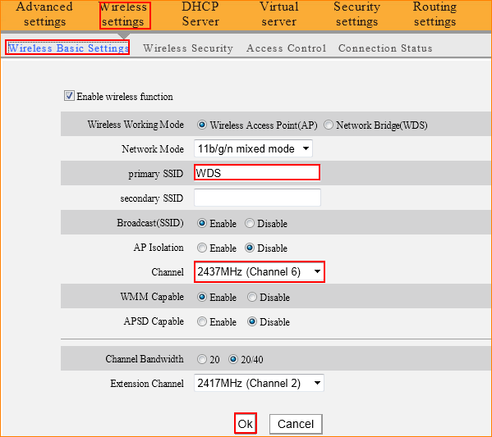

4. Click on Wireless Security, and choose WPA-PSK as the Security Mode and AES as the WPA Algorithms, and set a password for R1.
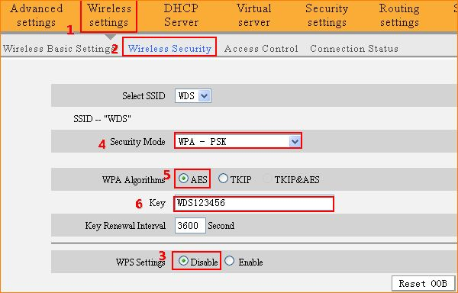

Settings in R2:
1. Open a web browser in PC3 which connects to R2, and in the address bar please type in 192.168.1.1, and then click Enter, then you will be in the management page of R2.

2. Click on the Advanced Settings in the right upward

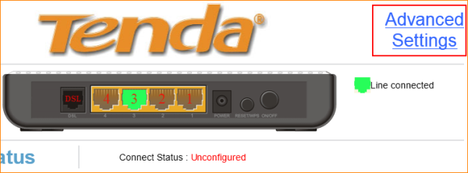

3. Click on Wireless, then set the same SSID and select the same Channel 6 as R1 in the Basic page, then click Apply.
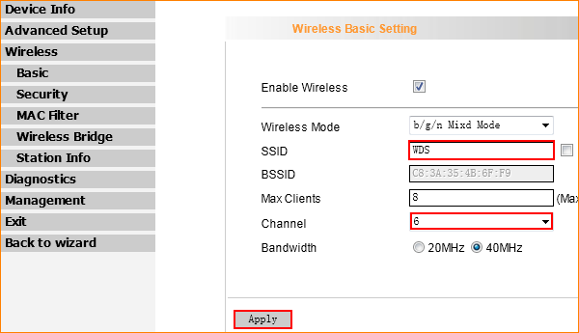

4. Click on Security, disable WPS and choose WPA-PSK as the Network Authentication and AES as the WPA Encryption, and set the passphrase the same as R1.

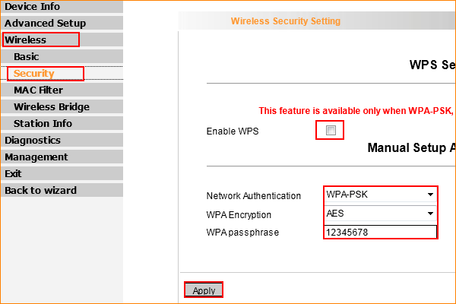

5. Click on Wireless Bridge, and add the MAC Address of R1.
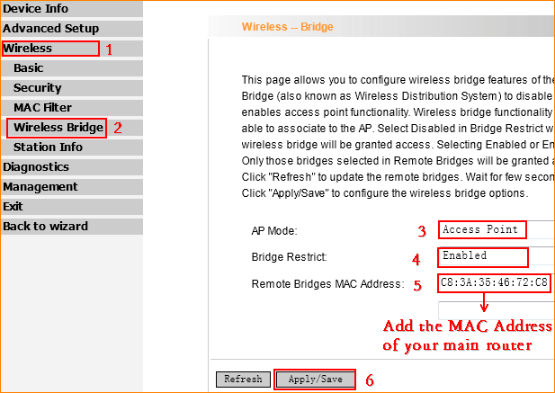
Tips: Generally, you can find the MAC Address of your router on the back of it.

6. Click on Advanced Setup, and then click on LAN and then change the LAN IP into 192.168.0.2.

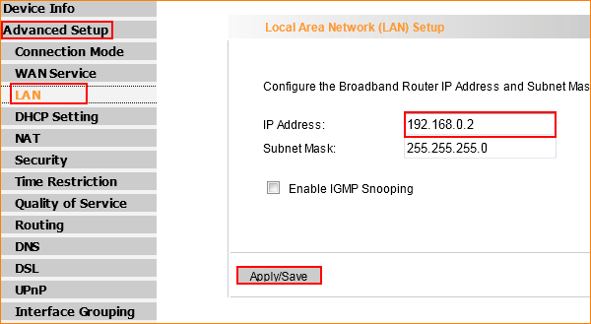

7. Click on DHCP Settings, and then disable the DHCP Server.

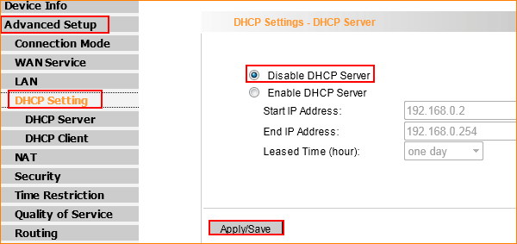

Now please go back to the management page of R1 to do the following settings.

1. Click on Wireless Basic Settings, choose Network Bridge (WDS) as the wireless working mode, then click Open Scan to find the SSID of R2 and select it to add its MAC address, then click OK to save.
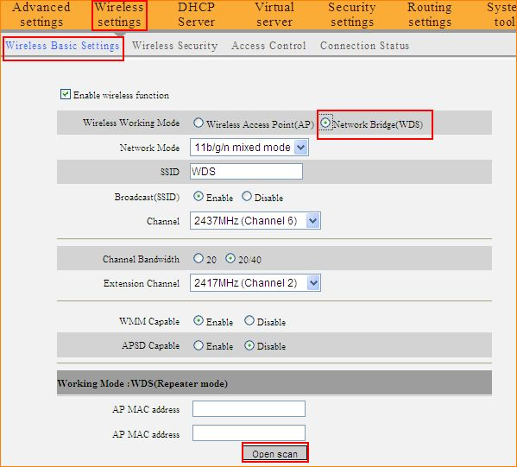
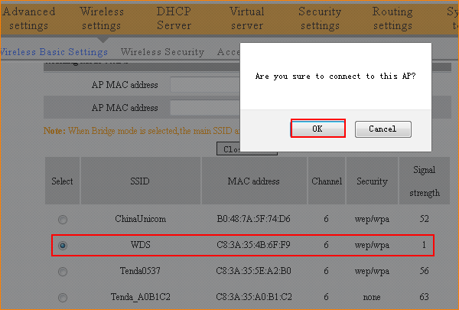

Now all the settings are done.
Please check on PC3 which is connected to R2, if it can get the IP address from R1 and have internet, it means the WDS has been setup successfully.

